[ HERO IMAGE PLACEHOLDER – will be shared on received from BRANDS]
ZONG FREEDOM LEAGUE 2026
This August, Freedom Comes with Rewards.
Complete missions across the Zong handset ecosystem. Earn Freedom Points. Climb the League. Win big this Independence Month.
JOIN THE LEAGUE

WHAT YOU CAN WIN (TBD)
- Weekly Draws —Surprise prizes
- Grand Independence Day Draw — flagship handsets & accessories
- Exclusive OEM prizes from our partners

We need to add pictures/visuals here of the potential prizes to attract customers
Reward structure and prize values to be finalized upon confirmation with OEM partners.
YOUR LEAGUE STATUS
BRONZE  0–650 Points | SILVER  650 – 1200 pts | GOLD  1200-3500 pts
Higher leagues unlock more lucky draw entries and exclusive rewards. (We need to highlight which one the customer is falling in)
YOUR MISSIONS
Track on your dashboard, tap any mission to see exactly how to complete it and how many points you’ll earn.
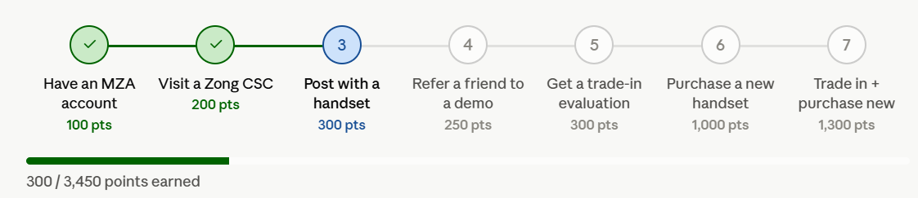
Mission Checklist: (Task list with check marks in front)
- Have an MZA Account
- Visit a Zong CSC
- Post With a Handset
- Refer a Friend to a Demo
- Get a Trade-In Evaluation
- Purchase a New Handset
- Trade In + Purchase New Handset
HOW TO COMPLETE
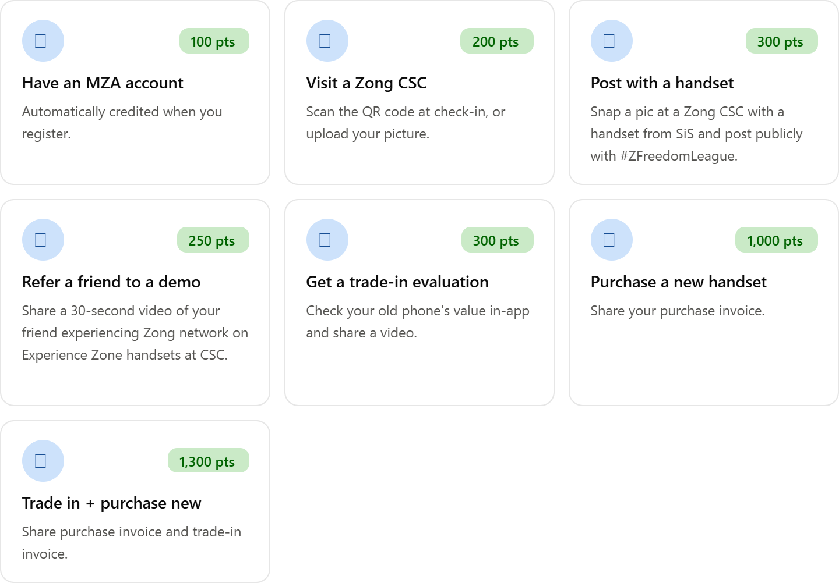

HOW IT WORKS
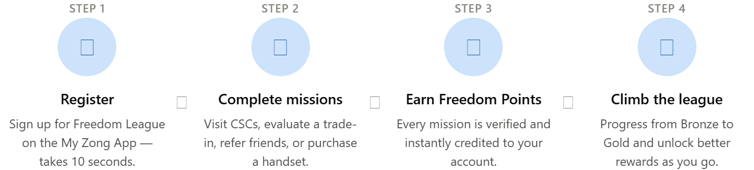

FAQs
- How do I join Freedom League? Open the My Zong App, register for Freedom League, and you're in. It takes about 10 seconds and comes with your first 100 points.
- Do I need to buy a handset to participate? No. You can earn points and win prizes through missions like visiting a CSC, getting a trade-in evaluation, or referring a frienda purchase isn't required to join or to earn rewards.
- How do I know my points were credited? Your MZA dashboard updates to show points. Once a mission is verified, your Freedom Points and league status update automatically — no need to wait or follow up.
- What counts as "posting publicly" for the CSC + handset mission? Your photo needs to be on a public profile or story (not private/restricted) with the hashtag #ZFreedomLeague, so it's visible for verification.
- Can I complete the same mission more than once? Some missions, like CSC visits, may be repeatable — check your dashboard for whether a mission shows as one-time or recurring. Trade-in evaluation and purchase-based missions are one-time per transaction.
- How long do I have to submit proof (photos, videos, invoices)? Submit your evidence within the same campaign visit or transaction for fastest verification. Late submissions may not be processed before the campaign ends.
- What happens if my trade-in evaluation says my phone isn't eligible? You still earn your Trade-In Evaluation points for completing the check as eligibility for the actual trade-in program is assessed separately.
- How are league tiers calculated? Your tier (Bronze, Silver, Gold) is based on your total accumulated Freedom Points at any given time. Higher tiers unlock more lucky draw entries and better rewards.
- When are winners announced? Weekly draw winners are announced throughout the campaign; the Grand Independence Day draw winner is announced at campaign close. Winners are notified directly via the My Zong App.
- Is there a cost to participate? No, Freedom League is free to join. Standard costs only apply if you choose to purchase a handset, trade in a device, or activate a bundle.
- Can I refer more than one friend? Yes, there's no cap mentioned on referrals, so you can earn the Refer-a-Friend points multiple times as long as each referral is a distinct new participant completing a demo.

In partnership with Samsung & Mercantile
#ZFreedomLeague | Campaign runs through Independence Month 1st to 14th August 2026 | T&Cs apply

